Page Object with Page Factory Model

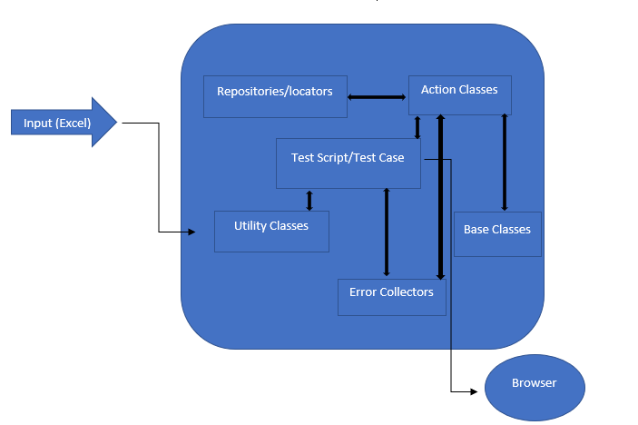

**Different blocks of the framework:**

Input:

The input used here in this framework is an Excel sheet. For each Test Case class, a workbook page is assigned.

The sheet is placed under the resources folder inside root directory.

Utility Class Package:

Utility package consists of all the utility classes (ex: Data provider, Excel reader, Mail sender, etc.,).

The main Test Case class directly calls and interacts with the utility classes for data input reading.

Test Script/Test Case Package:

This is the main package where all the test case classes are placed.

This is the first point of contact in the framework when a tester runs any testcase. It is responsible to interact with Action classes with the business logic, Error collector classes for reporting and validations, Utility classes for Input reading and launching a browser for the automated test.

Action Class Package:

This package contains all the individual classes where business logic is written corresponding to a particular feature (or) page (or) functionality in the application.

The main Test case class interacts with the action class. Action classes interact with repository/locator classes, Base class and error collector classes.

Base Class Package:

This package contains the base method classes.

All the reusable and common methods are provided inside base class. Base class is also responsible for initializing different browsers based on the input.

Error Collector Package:

This package contains the error collector classes.

These classes contain reporting, validation and error handling code.

**Advantages of using Page Factory Model:**

1. Code Reusability:

Writing the code once and reusing it in different tests.

1. Code Maintainability

Code changes only on Page Object Classes when a UI change occurs. It enhances test maintenance and reduces code duplication

1. Readability

Improves readability due to clean separation between test code and page specific code

1. Less Time Consumption
2. Reformation of automation scripts